Project Update: June 2016

We conducted our survey trips for the eastern and central Posavina area in Bosnia and Herzegovina. We registered 13 sightings, three individuals in eastern Posavina and 10 in central Posavina. Most of them are caught by funnel bottle traps, and some of them are found dead on road (DOR) or caught by net or by hand on the land during the night fields. We took morphometric and ecological measures for every caught individual. By this time we can proudly say that we found species in central and eastern parts of northern B&H and the number of new localities is now nine. There is a big chance to find them also in two parts of western investigated area, so during the upcoming period we continue with the educational programme and continue with the field trips and scientific part of the project.

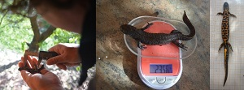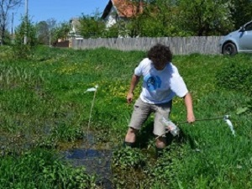
Taking morphological characteristics of caught individuals and setting newt traps.

