Project Update: May 2016

Otters make up the sub-family Lutrinae of the carnivore family Mustelidae, they are amphibious, foraging largely in aquatic habitats, both freshwater and marine, though they also take terrestrial prey. However there is an eminent threats to the species in Nyando wetland and eventual disappearance. By identifying the threats to otters, and taking the appropriate steps to overcome them, we can work towards preserving some of the important wetlands and waterways of the world.

Our research study has been accessing ‘‘The conservation knowledge and attitudes of riparian communities within Nyando Wetland on clawless otter towards its conservation’’ since January 2016.

Being the quarter progress report our observation are still limited to the eight selected areas in the eastern part of Nyando areas where we are ascertaining the knowledge, frequencies of otter sightings, other fauna, Attitude and perception (KAP) analysis.

We have managed to conduct our survey in the lower Nyando areas.

I must admit that of the 107 people interviewed (men and women) there is high knowledge by men (80%) as compared to women (20%) of the otter presence in the wetland, it is interesting to note that one out of five young adults have not seen the species nor have they heard about it.

For example our general KAP analysis on these four villages within Wasare on the attitude and perception are:

- Most fishermen interview felt that the clawless otter posed a great threat to their fishing activities and so should always be eliminated as a pest;
- Women on the other hand does not care about the species existence so long as it does not scare them from drawing water for domestic use; and
- Schoolchildren feels that the African clawless otter should be preserved as wild animals act as tourist attraction.

Respondents' perception of status may vary according to personal local experience, making regional comparisons difficult. The results of questionnaires can provide some useful baseline information but should be analysed with caution and never be relied upon verbatim.
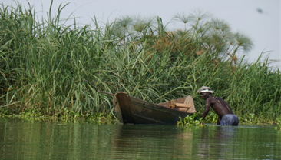
This picture shows a man harvesting sand within the banks of river Nyando.

In many areas along the riverine of the Nyando wetland sand is extracted directly from riverbeds, not only destroying natural vegetation but also sharply increasing the silt load of the water.

By identifying these threats (picture 1) to otters, and taking the appropriate steps to overcome these threats, we can work towards preserving some of the important wetlands and waterways of the world. A number of factors are involved in the decline, both in population and range, of several otter species. The most important of these are pollution, habitat destruction, and over hunting.

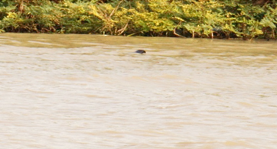
The small arrow points to an otter swimming down the stream after being aware of our presence. Due to the otter agility and distance of my camera I was not able to capture a perfect photogragh of the otter. African clawless otters are known to forage in family groups and/or pairs so sighting this lone individual was unusual.

Picture taken from Wasare River banks (0°15’S and 34°55’E). Notice the colour of the water (muddy) due to the annual flooding of Nyando River during long rains. The illegal cutting and charcoal burning in the hilly sides of Nandi has resulted into bare grounds being washed away by rain water. This irregular stream flow directly affects the distribution and abundance of the African clawless otter.

Our study has so confirmed that A. capensis territories vary in size from 1 – 5 km as in the case of Nyando wetland. This may be determined by the availability of food, although at some cases the results of the study shows that some territories are as small as 0.6 km.

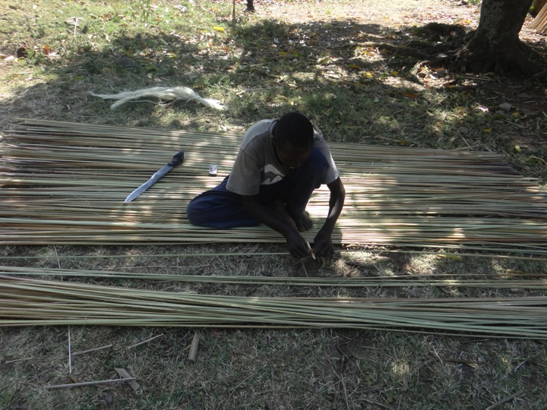
Some of the sites visited locals involves in a number of socio-economic activates such as mat making.

Although we have not yet encounter people hunting or pelts for that matter, we have heard of stories by respondents of having eaten otter meat. We anticipate to observe and/or hear these stories repeated as we proceed with our research study.
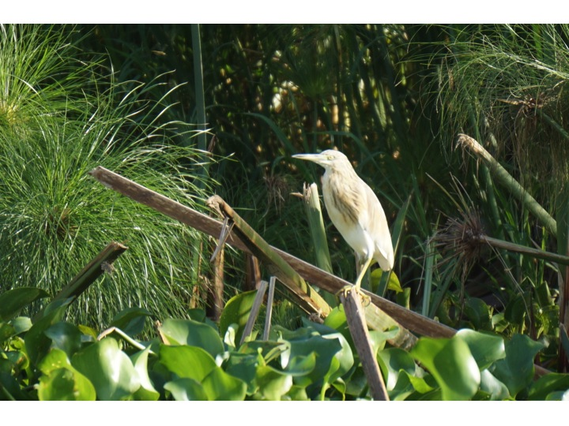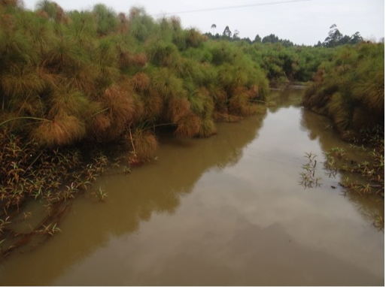
The impenetrable riparian vegetation comprises of Papyrus cyperus as the dominant vegetation. Such pristine habitat are very ideal for species survival.
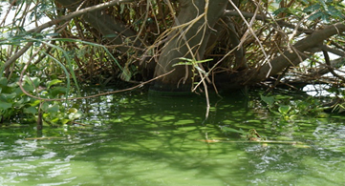
Throughout its range it occurs in rivers and lakes, and all streams and swamps in which there is sufficient water to support crabs, frogs, and catfish or mudfish. The presence of algae bloom in this habitat prohibits the availability of the food chain for the clawless otter which is in the top of the chain.

Challenges
Weather conditions have adversely affected the ease of finding scats and prints. The whole of the country is right now experiencing long rains (March-May) periods of heavy rainfall can result in most signs being washed away.

Conclusion
The long-term responses needed for conservation of otters involve major changes in the outlooks of people and governments. The growing acceptance of the biological and economic importance of wetlands through the Ramsar convention is a favourable sign of change. Still, much more needs be done to enhance regard for the intrinsic as well as extrinsic values of the ecosystems that otters inhabit.The study have started in strong research ground and the combinations of attitudes and perceptions will provide our need and means of laying a foot to effective awareness creation in future. In some instances we provided our interviewees with Aonyx capensis photos just to make them aware of the species we were inquiring about.

The pre-testing exercise was quiet successful and has culminated to training session for the research team.

The reaming sites are highly populated and our perception is that all our objectives are going to be met in each projects as had been the case in earlier field surveys.

