Project Update: May 2016

During this 3-month period we executed two expeditions to National Park Alejandro de Humboldt. Environmental variables for seven work stations located in three rivers (Toa, Duaba and Miel) were recorded during expeditions. Geographical coordinates were registered for all locations too. We accomplished counts and caught of specimens in order to assess abundance patterns of wild populations of Nandopsis ramsdeni (target species).

In addition, we accomplished some informal talks with local people (mainly with fishermen) in order to know about fishing practices in the area (e. g. which species they mostly catch, what kind of fishing gear they use, where are priority sites for fishing cichlid species in the area, etc.) We characterized and photographed all habitats in which we accomplished both fish sighting and measuring of environmental variables.

Photos

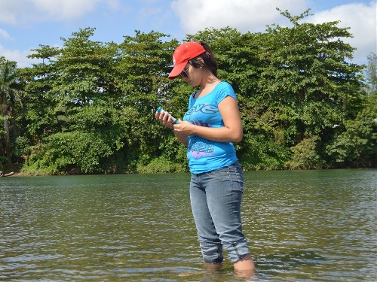
Yulima Gonzalez (project leader) registering water parameters at Toa River.

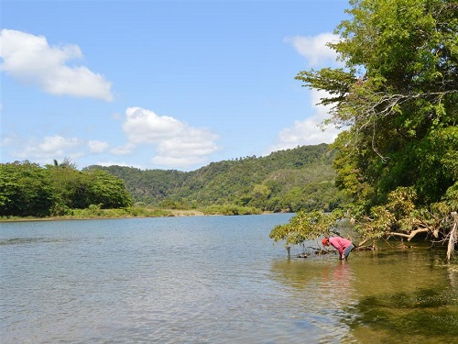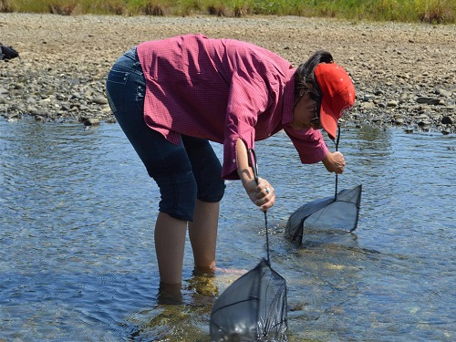
Yulima Gonzalez (project leader) looking for young fish of the target species in shallow areas at Toa River.

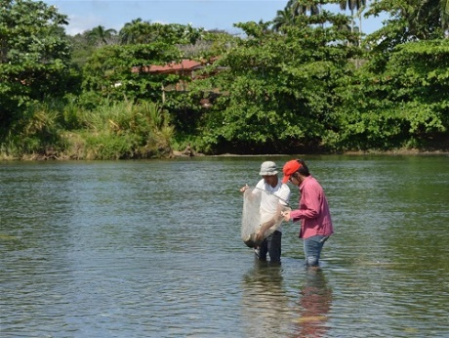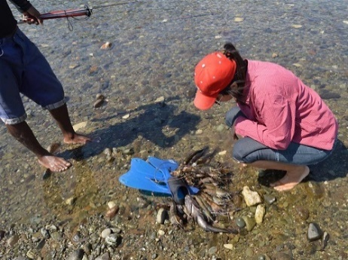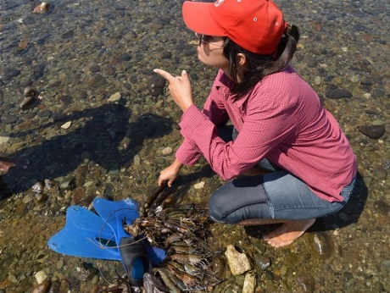
Yulima Gonzalez (project leader) talking with local fishermen at Toa River.

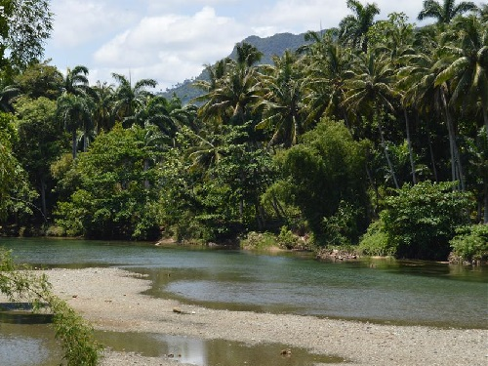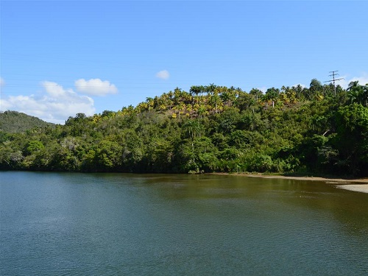
Typical biotopes for reproduction of Nandopsis ramsdeni (left: Duaba River and right: Toa River)

