Project Update: February 2016
Period October 2015- January 2016
Initial meetings involving conservation authorities and project collaborators were done in order to ensure the success of future project´s tasks. We executed two expeditions to the National Park Alejandro de Humboldt and seven work stations were stablished during the field work. In addition, we measured abiotic variables for each point during the period (corresponding to the dry period in the Cuban archipelago).
We were able to identify specimens of Nandopsis tetracanthus in each sampled point, despite the species’ abundance was quite variable among different sampled sites. This result is closely related with specific habitat features and requirements of the target species. These habitats were characterised and photographed in order to accomplish detailed comparisons among them during the course of the project.
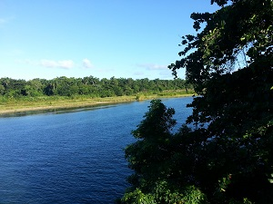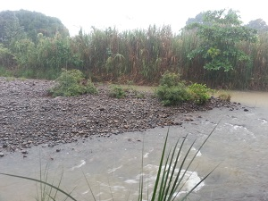
Left: A wide river in the National Park plenty of calm waters. Right: A rapid stream during winter rains.

