Project Update: February 2016

Between October to November 2015, pools were drilled onto rock revetments during low tide over a period of 3 weeks at three sites along the east coast of Penang Island. A total of 30 pools with varying depths were drilled at each site using core borers supplied by contractors.
The first monitoring exercise was conducted in December 2015 using quadrats shaped to fit the sides and base of the pools. The number of cells filled with algae were counted. A sample of the algae was taken to the laboratory for further identifications. Fauna within the quadrat was identified to species level and the number of individuals for each species was counted. Each quadrat was photographed. Fifteen photo quadrats were also taken for emergent rock and naturally occurring rock pools, whenever they were present. This is to compare species indices between drilled pools, emergent rock, and naturally occurring pools.

Results from monitoring revealed significantly higher species abundance, diversity and richness in drilled pools compared to emergent rock. These species indices were also higher in drilled pools compared to in naturally occurring pools although conclusions are not concrete due to limited numbers of naturally occurring rock pools. Green algae was present in almost all the drilled pools creating green lungs for other organisms to take habitat there. Dissolved oxygen was notably higher in these pools and the hundreds of young gastropods were observed to be attached, exclusively, on the fronds of the algae. Limpets, neritids, small fish, shrimps, sea cucumbers, polychaetes, and sea slugs also favoured these pools as opposed emergent rock. Crabs use these pools as shelter to molt as molted shells were found in the drilled pools. Besides these, thousands of gastropod eggs were seen in drilled pools too indicating their applicability in various stages of life of the coastal organisms.

Monitoring of these pools will continue for the next 2 months to complete the 6-month monitoring period.

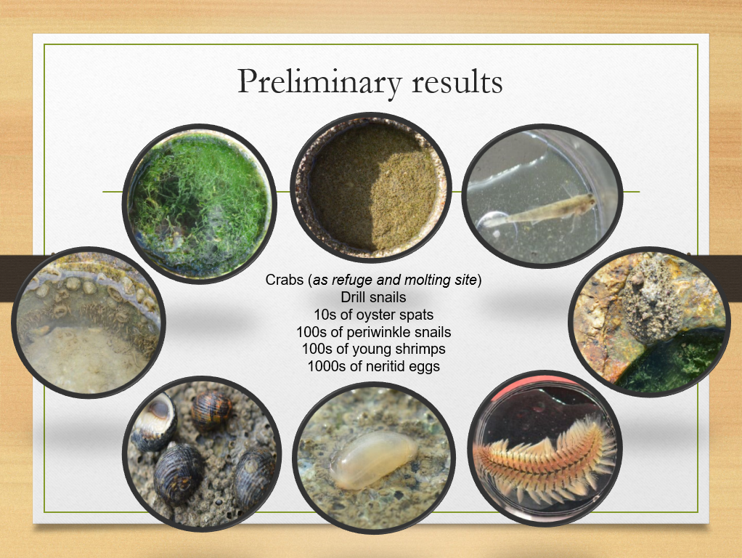
Coastal organisms found in the drilled pools one month after installation. Clockwise from the top: Barnacles, fish, sea slugs, polychaetes, sea cucumber, neritids, limpets, green algae.
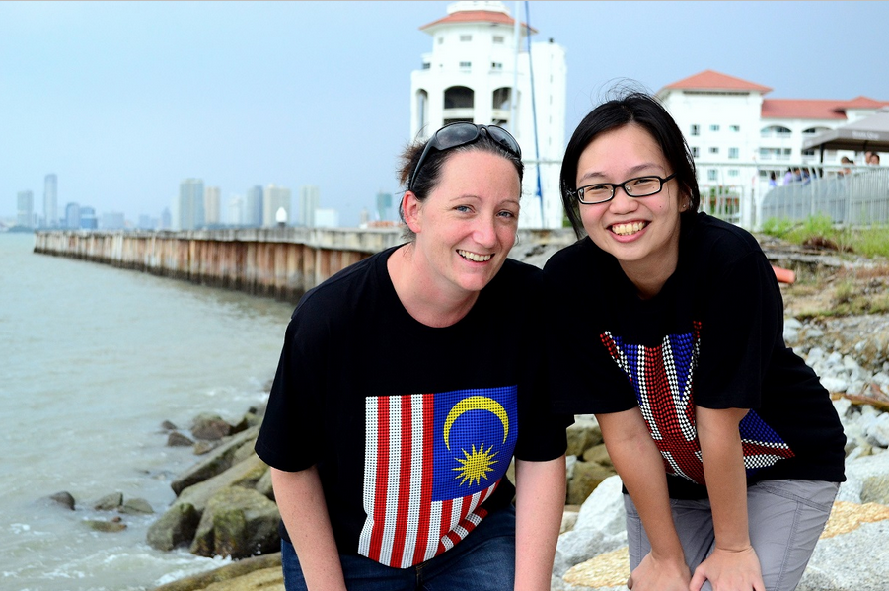
Dr Louise Firth (left) and Dr Chee Su Yin (right) on the rock revetments of Straits Quay, Penang

