Project Update: November 2015

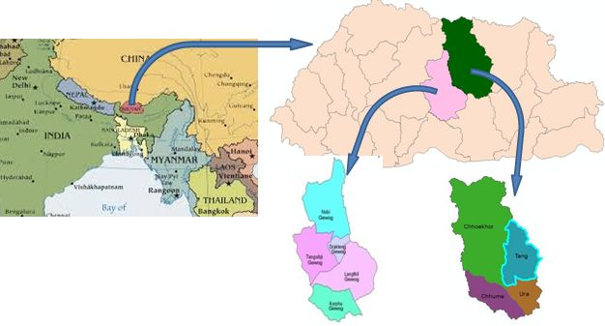
The project on Ecology, Diversity and Conservation Implication of Bees and Wasps (Hymenoptera: Aculeata) in North Central Bhutan commenced in September, 2015. Prior to the field study village naturalist and individual respondents were interviewed to get general idea and information on aculeate insects, their habitat and nesting areas in the study area. This is the first phase of field survey and data collection; the survey team comprising of staff from NRDCL, Department of Forest and the students from the college of Natural Resources, RUB has covered at least two Geogs in each District (Chhokhor and Chummey Geog under Bumthang District and Tangsibji and Nubi Geog under Trongsa District) within September, 2015 and October, 2015. Extensive area will be covered in the second phase (main survey) of field survey that will commence from February, 2016 until early August, 2016.
Fig 1: Study Area

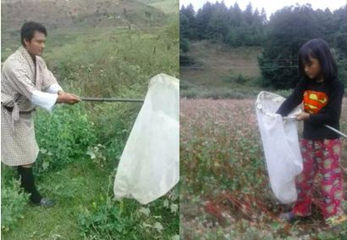
The “opportunistic visual encounter” and “transect walk” adopted. Photographs were taken using digital camera. GPS handset is used to mark location. Bees and wasps will be collected with the help of sweeping insect net and also by using various baits like meats, fruits and beers and collected using nets and forceps as the insects feed on these baits. Sample specimens were preserved as and when collected from the field with proper information. Insects were killed by placing them in the killing jar containing cotton soaked in 70% ethanol. After killing, the samples are pinned stretched and mounted in the insect collecting box and leveled properly with Location and GPS coordinates, the name of collector, collection date altitude of an area etc, and preserved in the Laboratory in College of Natural Resources, Lobesa for further identification.
Fig 2: Specimen collection using insect net
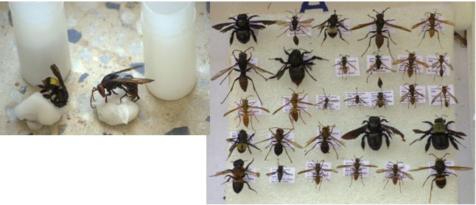
Fig 3: Top: Killing using cotton soaked in 70% ethanol.
Right: Preservation of specimens in the inset collecting box.

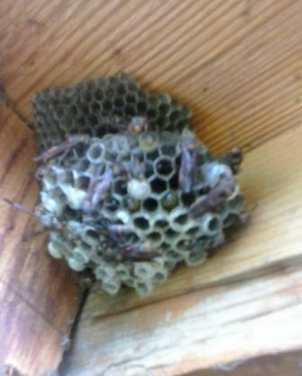
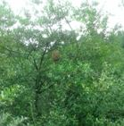
Fig 5: Nest of Hornet
Fig 4: Nest of Hornet

