Project Update: May 2016

To the date the survey covered 23 villages and six Gewogs (smallest public administration unit made up of a block of villages) and two Dzongkhags (districts) in north central Bhutan. The study revealed the presence of 34 species of bees and wasps under eight different families. In total, 503 individuals were sampled during the study period. Species diversity was determined with Shannon-Weiner diversity index. The obtained results showed species diversity, evenness and species richness were more observable in Trongsa Dzongkhag compared to Bumthang Dzongkhag. Of the total 34 species, 20 were identified up to species level, nine to genus level and five to family level.

Out of total aculeates (bees and wasps) catch, 200 were male and 303 were female. Apidae was the most dominant family in terms of number of species. More than 50% of the families were social insects. Species diversity and richness of bees and wasps are found to be highest at altitudinal range of 2500-3000 m asl with 51 individuals of 13 species. Evenness of bees and wasps species is found to be highest at 1000-1500 m asl. The survey has been done in six major habitat types in the study area viz. agriculture land, forest, grassland, kitchen garden, orchards and settlements. Of the total catch samples, the highest percentage of bees and wasps were caught from forested area followed by agriculture land.

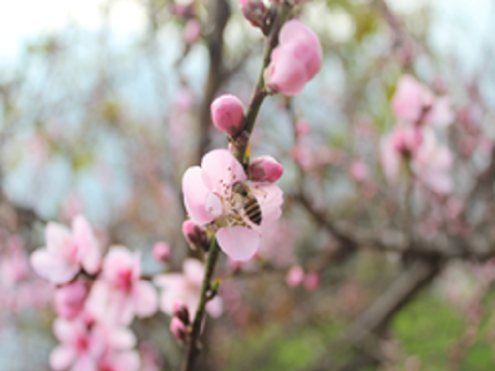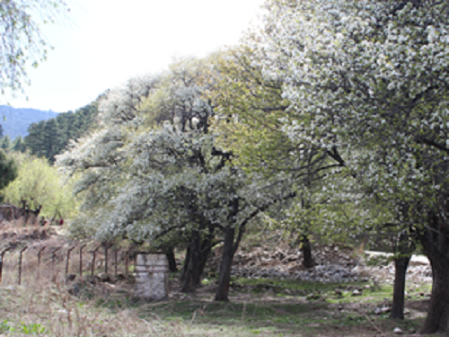
Left
Left: Apis cerana foraging on peach flower in Trongsa. Right: Field of pear trees in Bumthang.

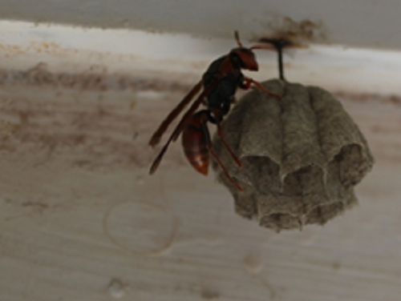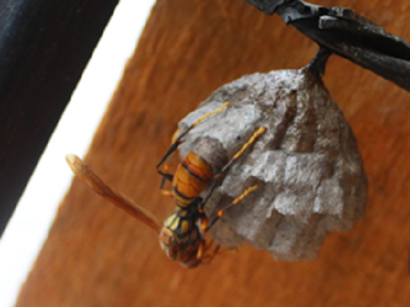
Left: Polistes gigas (queen) constructing nest. Right: Polistes olivaceus (queen) laying egg.

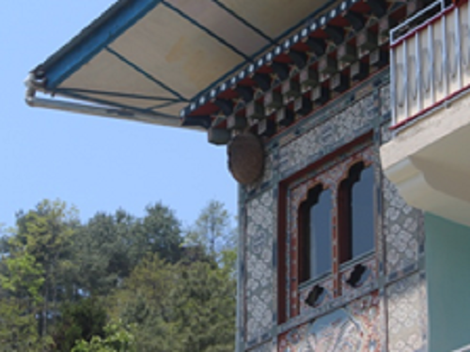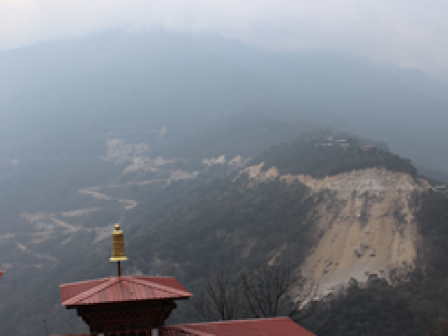
L

LLLeft: Nest of hornets. Right: Developmental activities causing threats to the bees and wasps.

