Project Update: November 2015

An accurate study of collected material showed that we found one new species for the Kamchatka region – Potamogeton sibiricus A. Benn. and eight new species for the Commander Islands. These species are Botrychium boreale Milde., Callitriche subanceps Petrov, Eleocharis acicularis (L.) Roem. et Schult., Isoёtes × paratunica D. F. Brunton, Mochalova & A. A. Bobrov, Potamogeton fryeri A. Benn., Potamogeton perfoliatus L., Ranunculus ashibetsuensis Wiegleb. and Stuckenia pectinata (L.) Börner. Now we are preparing an article about these findings for publication in a scientific journal.

At the end of September 2015 our group made a presentation on field part of the project in Moscow South-West High School No. 1543 for its students and teachers.

The final report with detailed information on these species and on the investigated endangered species we will provide in the Rufford Foundation by the end of December 2015.

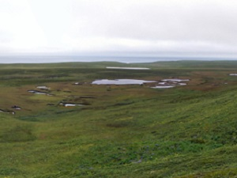
Group of lakes in the north of the Bering Island where we found two species of quillwort – Isoetes × paratunica and Isoetes asiatica (photo by N. Tikhomirov)

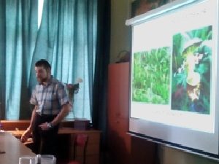
Yury Kopylov-Guskov is presenting the results of investigation of endangered species in Moscow South-West High School No. 1543 (September 2015; photo by N. Tikhomirov)

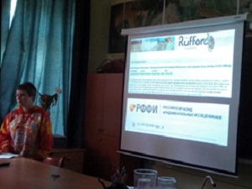
Polina Volkova is finishing the presentation in Moscow South-West High School No. 1543 (September 2015) with the appreciation for Foundations supported our work (photo by Yu. Kopylov-Guskov)

