Project Update: November 2015

The reforestation
Over the past 3 months since the commencement of the project, the community has planted and are raising over 8,651 seedlings in the nursery shelter. We are planning to plant the remaining 1,500 by the end of November 2015. We have already performed root pruning for a couple of fast growing species including pod mahogany and Acacia galpinii. Meanwhile, with the community we have already started preparing the allocated site for planting.

The Economic Empowerment

On the economic empowerment, we have supported 44 men and women with capital to start small scale businesses. Some have venture into selling of food items, others grocery shops, other into production and selling of fuel efficient stoves whiles others selling second hand clothes. They choose the businesses that would easily bring income to replace their former production and selling of charcoal.

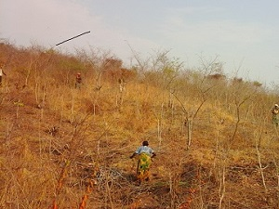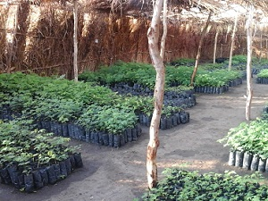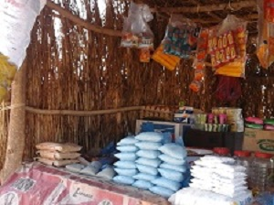

Left: The community clearing the site in preparation for planting. Middle: Seedlings in our nursery shelter. Right: A small business for one of our community member.

