Project Update: February 2016

The community, under the supervision of the Forest Reserve Committee, cohesively managed to nurture the tree nursery seedlings up until the time of planting. Beginning from December of 2015 with the commencement of the rainy season, the community members began by digging holes with the first rains. In January 2016 we began planting the trees and finished on 9th February. We have planted 8,100 seedlings in the forest reserve and have planted around 1,000 seedlings at the St. Agnes Primary School formally known as Ndurwe Primary School. The school has established its own woodlot with various plant species.

There is another development that is taking place in Mwakifwamba village in connection our project. The government through the department of Forestry has initiated a project to rehabilitate Ndurwe River which start in the hills where our reserve is located.

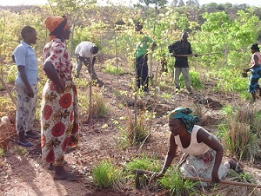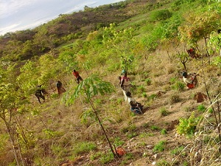
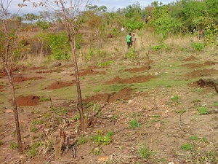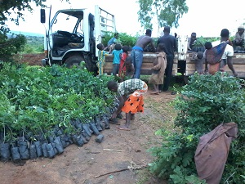
The photographs were taken when the digging begun and when we transferred the seedlings to a place near the reserve to ready for planting.

