Project Update: March 2016

We performed field research on six different sites where we recorded 52 species (32 Ensifera and 20 Caelifera) which represents 28% of the total known Orthoptera in Serbia. The most significant founding is a population of Pholidoptera transsylvanica, species of European importance and Carpathian endemic species which was known only from mountains in eastern and western Serbia. Very important is record of Stenobothrus crassipes on three sites, which shows there are preserved steppic habitats on this mountain. Species: Isophya speciosa, Barbitistes serricauda, Leptophyes discoidalis, Pholidoptera littoralis similis and Pholidoptera fallax are for the first time recorded in this part of Serbia.

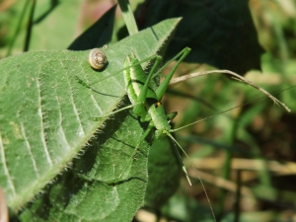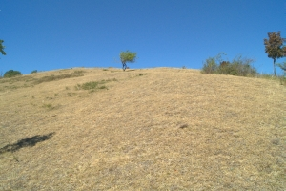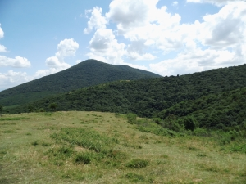
Left: Leptophyes discoidalis. Photo by Ivkovic Slobodan. Middle: Malo Srediste. Photo by Ivkovic Slobodan. Right: Markovac. Photo by Ivkovic Slobodan.
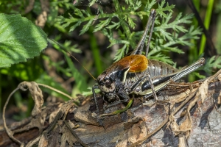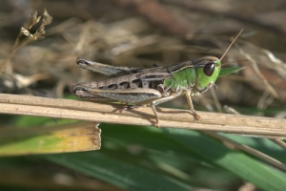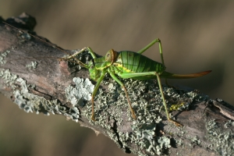
Left: Pholidoptera transsylvanica. Photo by Ionuț Iorgu. Middle: Stenobothrus crassipes. Photo by Laslo Horvat. Right: Ephippiger ephippiger. Photo by Laslo Horvat.

