Project Update: May 2016

The project surveys led to discovery of five new species and one new genus. Images are attached for the Rufford website. Here is a list of publications form the survey and there are several more in review or in press of which I shall update you soon.

Sanap, R. & Mirza, Z. A. 2014. A new iridescent tarantula of the genus Thrigmopoeus Pocock, 1899 from Western Ghats, India, C. R. Biologies, http://dx.doi.org/10.1016/j.crvi.2014.06.003

Sanap, R & Mirza, Z.A. 2015. A new species of trapdoor spider of the genus Heligmomerus Simon 1892 from Western Ghats, India. Journal of Asia Pacific Biodiversity 8(3): 242–246.

Mirza, Z.A., Sanap, R., Raju, D., Gawai, A. & Ghadekar, P (2014) A new species of lizard of the genus Eublepharis (Squamata: Eublepharidae) from India. Phyllomedusa, 13(2): 75–90.

Mirza, Z. A., Sanap, R. V. & Kunte. K. (2016) A new species of buthid scorpion of the genus Thaicharmus Kovarik 1995 (Scorpiones: Buthidae) from northeast India. Euscorpius — Occasional Publications in Scorpiology, 215: 1–11.

Mirza, Z. A., Sanap, R. V. & Zambre, A. (2015) A new species of the enigmatic scorpion genus Chiromachetes Pocock, 1899 from Western Ghats, India. Euscorpius — Occasional Publications in Scorpiology, 212: 1–10.

Mirza, Z. A., Sanap, R. V. & Kunte. K. (2016) A new genus and new species of diplurid spider (Araneae: Mygalomorphae: Dipluridae) from northeast India. Journal of Asia Pacific Biodiversity.

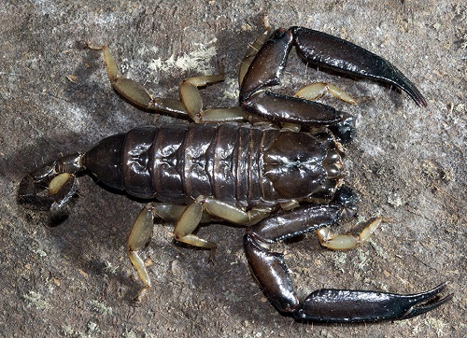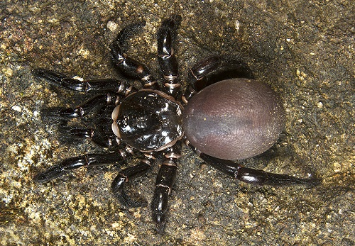
Chiromachetes sahyadriensis Heligmomerus maximus
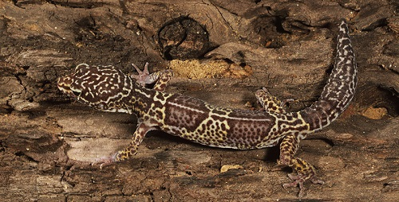
Eublepharis satpuraensis

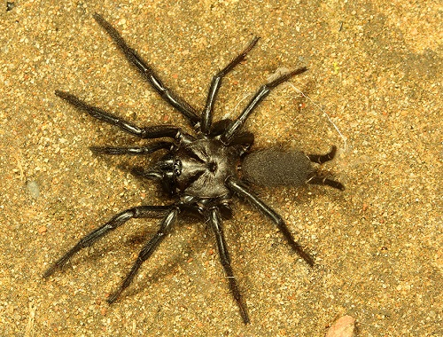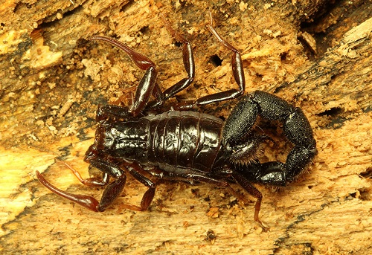
Orientothele alyratus Thaicharmus guptai

