Project Update: December 2013
The autumn expeditions (October-November 2013) have partly shed light on the pattern of passage of the endangered white-headed ruddy duck in Crimea. The birds apparently use water bodies in eastern Crimea for staying on southward migration. The passage already started in last days of October and probably was at its peak in early November 2013. The numbers decreased significantly by mid-November. At the same time only two lone birds were seen in the western Crimea despite several lakes in this area hosted groups of the white-headed ruddy ducks in spring 2013. The team was lucky for the highest single count of the species ever made in Crimea – 132 individuals in the southern part of Eastern Sivash on 4th November 2013. Our surveys indicate that white-headed ruddy ducks consistently use only certain lakes or reservoirs for staging during migration. In autumn the disturbance by hunters may have negative effects on the distribution of the species in the Crimea.
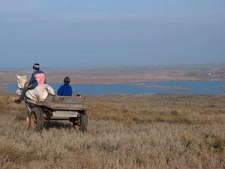
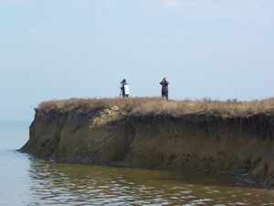
Uvarovo ponds host some white-headed ruddy ducks in spring but not in autumn when hunting scares birds away.
Counts at the Sivash bay.

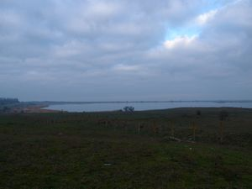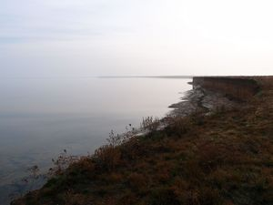
Samarli reservoir in the eastern Crimea is equally important for the white-headed ruddy ducks both in the spring and in the autumn.

Southern shoreline of the eastern part of Sivash bay – the most important staging area for migrating white-headed ruddy ducks in autumn

